Project Design Phase-II

Data Flow Diagram & User Stories

Date | 19 October 2022
Team ID | PNT2022TMID51154
Project Name | AI-Powered Nutrition Analyzer For Fitness Enthusiasts
Maximum Marks | 4 Marks

Data Flow Diagrams:

DFD-1(Login):

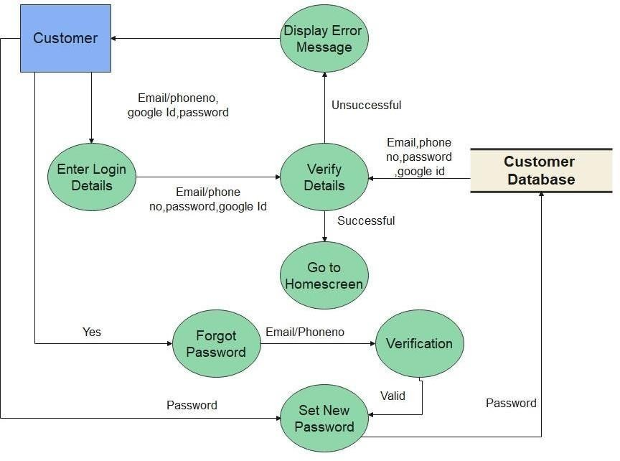

DFD-1(Registration):

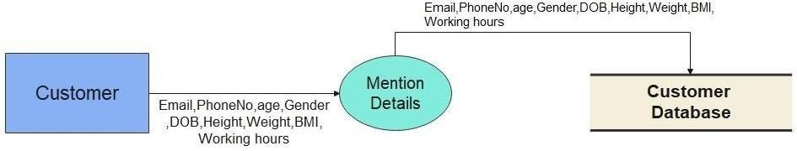

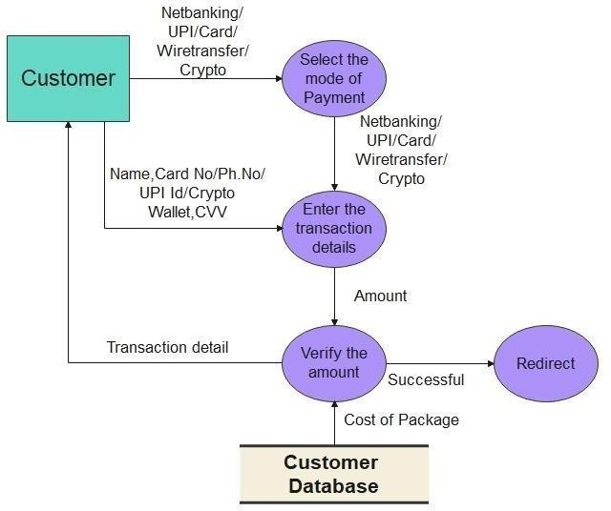
DFD-1(Payment):

DFD-0:

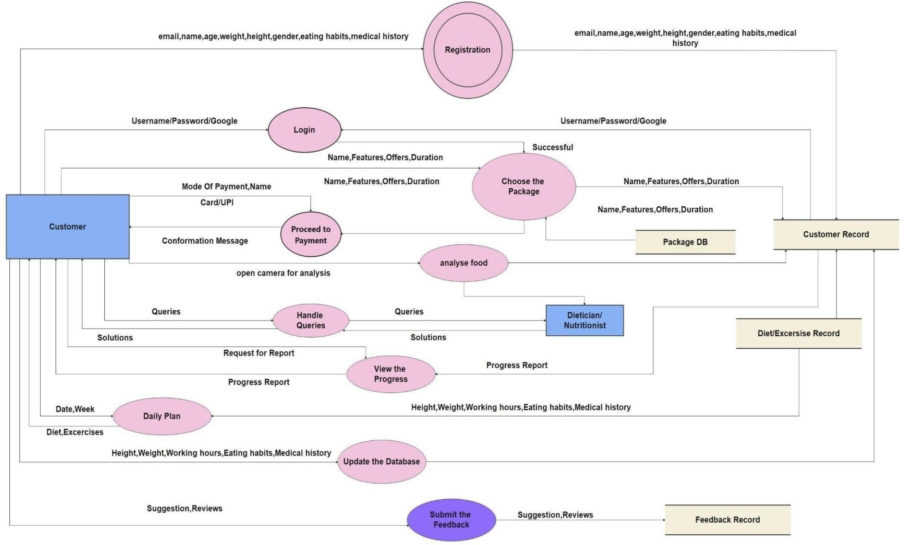

User Stories
Use the below template to list all the user stories for the product.

User Type | Functional Requirement (Epic) | User Story Number | User Story / Task | Acceptance criteria | Priority | Release
Customer | Registration | USN-1 | As a user, I can register for the application by entering my email, password, and confirming my password. | I can access my account / dashboard | High | Sprint-1
 |  | USN-2 | As a user, I will receive confirmation email once I have registered for the application | I can receive confirmation email & click confirm | High | Sprint-1
 |  | USN-3 | As a user, I can register for the application through Google | I can register & access the dashboard with Facebook Login | Low | Sprint-2
 |  | USN-4 | As a user, I can register for the application through Microsoft | I can access the Dashboard with Microsoft. | Medium | Sprint-1
 | Login | USN-5 | As a user, I can log into the application by entering email & password | I can login the Application by entering password | High | Sprint-1
 | Main Interface | USN-6 | As a user I can view my calorie intake by clicking photo of the food I eat | Access the proper information about the nutrition and the calorie  intake | High | Sprint-2
 | Package DB, Dashboard | USN-7 | As a user I can choose variety of packages based on my requirement | Selecting an appropriate package | Medium | Sprint-2
Customer Care Executive | Feedbacks DB , Tollfree number, chat bot | USN-8 | As a customer care executive, I collect feedbacks from customers | Maintaining proper environment for the customers | High | Sprint-2
Dietitian | Customer Record | USN-9 | As a dietitian I provide daily plans for the betterment of the user | Positive results from user | High | Sprint-2
Administrator | Dashboard | USN-10 | As an administrator I take care of all the operations which takes place in the app | Zero issues from the user | High | Sprint-2

